Pokhara University

Level: Bachelor | Semester – Fall | Year : 2010
Programme: BE |  | Full Marks : 100
 |  | Pass Mark : 45
Course: Numerical Method |  | Time : 3 hrs

Candidates are required to give their answers in their own words as far as practicable.
The figures in the margin indicate full marks.

Attempt all the questions.

1. | - Find a root of the equation xsinx + cosx = 0 using Newton’s Method so that relative error is less than 0.1%.  - Find a real root of the equation x³-2x-5 = 0 correct to three decimal places using secant method. | 7  8
2. | - Find Newton’s forward difference interpolating polynomial for the following data. Use the obtained formula to estimate the value of f (0.24).  - Fit an exponential equation of the form y= ae^{bx} using the least square method from the following data. | 8  7
  x | 0.1 | 0.2 | 0.3 | 0.4 | 0.5
  f(x) | 1.40 | 1.56 | 1.76 | 2.00 | 2.28
  x | 1 | 2 | 3 | 4 | 5 | 6
  y | 1.65 | 2.70 | 4.50 | 7.35 | 12.2 | 15
3. | - Find the approximate value of y=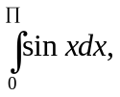 using  - Trapezoidal Rule  - Simpson’s 1/3 rule by dividing the range of integration into 6 equal parts.  - Evaluate the integral I =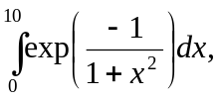using Gauss quadrature formula with n = 2 and n = 3. | 8  7
4. | - Solve the following system of linear equations using Gauss Elimination Method .Use partial pivoting whenever necessary.  b+3c+2d=19  3b+2c+2d=20  a+4b+2d=17  -2a+2b+c+d=9  - Use LU decomposition method and solve  5x₁-2x₂+x₃=4  7x₁+x₂-5x₃=8  3x₁+7x₂+4x₃=10 | 8  7
5. | - Solve the differential equation for y (0.25) using RK 4th order method. 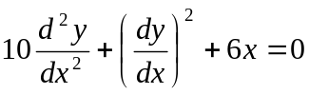, with y(0) = l and y¹(0) = 0. (take h = 0.25).  - Solve the differential equation y¹ = x + y using appropriate method within 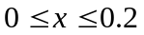with y(0) = 1. | 7  8
6. | - Solve the Poisson equation, ² f= 2x²y² over the square domain 0 ≤x ≤3 and 0≤ y ≤3 with f= 0 on the boundary with h=1. Show the necessary steps for solving simultaneous equations by any of the method known to you.  - Evaluate the square root of 3 using the equation x²-3=0 by applying the fixed point iteration algorithm correct to three decimal places. | 10  5
7. | Write short notes (Any Two):  - pivoting  - algorithm to use bisection method  - cubic spline interpolation | 2×5

